

**WP2: Training of trainers for participation at CTIs**

**Training contents and programme**

**WP Leader: ARCA**

**November 30, 2016**

**Document Data**

|  |  |
| --- | --- |
| **Author** | Stefania Zanna, ARCA |
| **Distribution List** | **CO** (Confidential, only for members of the Consortium (including the Commission Services) |
| **Document Version** | 01 |
| **Reviewed by** | ARCA |
| **Review Date** | 30/11/2016 |

|  |  |  |
| --- | --- | --- |
| **Version** | **Date** | **Author/Organization** |
|  |  |  |
|  |  |  |
|  |  |  |

**Disclaimer**

This project has been funded by the Erasmus+ Programme of the European Union.

The information and views set out in this publication re those of the author(s) and do not necessarily reflect the official opinion of the European Union. Neither the European Union institutions and bodies nor any person acting on their behalf may be held responsible for the use which may be made of the information contained therein.

Reproduction is authorised provided the source is acknowledged.

Copyright © INVENT Consortium, 2015-2017

Table of contents

I. Introduction 4

II. Executive summary 4

III. Methodology applied 5

III.1 Needs expressed during the survey phase 5

III.2 Results of the analysis of information included in the questionnaires submitted to staff units 8

IV. Contents of the training and programme of activities 13

IV.1 First training week: March 2017 15

IV.2 From March 2017 to September 2017 17

IV.3 Second training week: September 2017 18

IV.4 From September 2017 to January 2018 19

IV.5 Third training week: January 2018 20

V. Evaluation of the training 21

Annex 1 –Questionnaire for the evaluation of host organizations 22

Annex 2 - Questionnaire for the evaluation of CTIs’ staff 25

# Introduction

**INVENT** – Promotion of Innovation Culture in the Higher Education in Jordan, is the ERASMUS+ project, which aims at institutionalizing innovation, technology transfer, and capacity building within the Jordanian universities so that they become a pillar in the development of the national economy. The project concentrates on strengthening and enhancing the role of higher education institutes and universities in innovation capacity building, technology transfer and commercialization of applied scientific research outcome in Jordan.

The project will help to utilize the abundant scientific research production in two ways: first by giving the chance to the researchers to apply their research results, and second by providing a clear view of the technological need of the local industries so that the research and researchers priorities can be well identified. Another important objective of this project is to enhance the sector of innovation and technology transfer through **capacity building of staff** and **raising the awareness** of the innovation importance among the university’s researchers and the local businesses.

The project aims and objectives will be achieved via establishing Centers for Transfer of Innovation (CTI) at selected Jordanian universities. The centers will help in the implanting and further development of the National Policy and Strategy for Science, Technology and Innovation which is the base for all currently ongoing and planned innovation support activities. INVENT project will enable the CTI to support reality-related introduction of research results into the educational processes and industrial application.

The basic results of the project activities are the establishment of four Centers for transfer of innovation (CTI) at the Jordanian universities and other two at departments at non-academic organizations and institutions. Their activity is the provision of entrepreneurs with innovations for introduction in the process of production.

This document aims to give a general structure and contents of the training to be offered to CTIs staff participating to mobility.

# Executive summary

Through the research activities undertaken in previous phases of the project, INVENT project already underlined the relevance and importance of the organization of innovation centers called CTIs (Centres for the Transfer on Innovation), similar to the Centers that exist in Europe, within University structures or other bodies in the Jordanian territory. However, Jordanians partners at that moment did not have not have enough experience in the establishment of such Centers.

Moreover, the international dimension that Universities in Jordan strongly promote as well as the need of changing the traditional functioning of the market and economy in Jordan, has led them to the acknowledgment of the urgent need for the establishment and development of such facilities and building the capacities of internal staff.

Given that as a general context, the goal of this project activity was decided to be to learn from European experience of CTIs staff and other organizations. The objective of this document will be therefore to complete the capacity building plan setting more precise contents of he training to be offered by EU partners for CTIs staff development in the field of innovation and entrepreneurship.

The training of the CTIs staff will be important in order to give them a precise representation of strategy, methodology, mechanism, form and means of innovation and training activities of the European Centers.

CTIs staff participating to mobility visits will also act as ‘innovation ambassadors’, facilitating innovation transfer into local development programmes. The shared team of facilitators, trained through the project, will assist the technology transfer process from then onwards and establish a long lasting network of cooperation among the Mediterranean labs and institutions involved.

# Methodology applied

In order to define the training path to be followed by CTIs officers, ARCa, who was in charge of this activitiy, firstly contacted the MPCs for the list of units’ staff recruitment. At the same time, a questionnaire was designed in order to survey the competencies and expectations of the 16 units’ staff. Moreover another questionnaire template was designed addressed to the hosting European research and training institutions to highlight their main areas of expertise and cross this information with the requested expressed by the staff. Additional font of information was the needs research realised in Jordan, interviewing Universities, bodies and stakeholders.

The training needs expressed were then matched, as said, with the potential offer of the host institutions, namely:

1. University of Deusto (Spain)
2. Paulo & Beatriz Consultores Associados, Lda (Portugal)
3. Consorzio ARCA, Palermo (Italy)
4. University of Cyprus, Nicosia (Cyprus)

## III.1 Needs expressed during the survey phase

Within WP1 two surveys were developed: one for the industry, and the other for the academia. Both surveys focused on identifying the barriers between the industry and academia in Jordan in order to develop a mechanism to bridge the gap between academia and industry. More than 125 surveys for the different industrial sectors and more than 130 from different higher education Institutes (HEIs) in Jordan have been analyzed. The analysis of the data enabled us to identify the local needs for training of the staff who will be working in the CTIs.

We hereby list only those results which were useful for targeting the training plan:

From the Faculty Members Survey

**4.** The reasons for the un-satisfying collaboration were shortage of the fund (38%), difficulties in dealing with the industrial partner’s management (25%), lack of productive communication (22%) and different priorities (16%).

**6.** Top 5 reasons why researchers get involved in joint projects with the industry are: getting funding (25%), acquiring practical knowledge (22%), having a field to test theories (20%), student internships (18%), and obtaining patentable innovations and business opportunities (15%).

**8.** About 84% indicated that they would support their university decision to establish a specialized center as a liaison between faculty members and the industry.

**9.** Among the factors preventing faculty members from undertaking industrial projects are: high teaching and administrative load (more than 50% agreed); the lack of labs in the industry (more than 50% agreed); the geographical location (about 50% agreed); the absence of clear procedure for the collaboration with the industry (more than 60% agreed); industrial collaboration is not considered a part of the duties (more than 65% agreed); and the lack of confidence to undertake industrial projects (55% agreed).

From the Industrial Survey

**4.** Most of the collaboration projects with universities were through students’ training (49%); and graduation or thesis projects (17%).

**6.** About half of the participants indicated that their experience with collaboration projects with universities was successful.

**7.** Among the reasons for unsuccessful collaboration are: difficulty in dealing with university administration (31%); different priorities (31%); and lack of communication (19%).

**8.** About 70% of the direct impact on the companies of the collaboration with universities were either developing new products or improving current products.

**10.** According to the participants, among the best ways to establish a partnership with universities are: meetings with faculty members (27%); support applied research (14%); and consultations (27%).

**12.** According to the participants, the services needed by the industry from the Technology Transer Offices (TTOs) are: Awareness of modern technologies (24%); applied research to develop/upgrade products (23%); and connection with other companies (17%).

**13.** According to the participants, factors to promote innovation and industrial inventions are: Establishment of Technology Transfer (TT) centers (30%); improving communication and building trust (23%); and improvement of mechanisms to promote applied research outcomes at universities.

Considering the above conclusions, the contents of the training will be specifically designed to try to respond to the needs expressed in the research phase. The table below summarises the main contents proposed through crossing the selected needs:

|  |  |
| --- | --- |
| **Research results by faculty members** | **Training contents** |
| 4. The reasons for the unsatisfying collaboration were shortage of the fund (38%), difficulties in dealing with the industrial partner’s management (25%), lack of productive communication (22%) and different priorities (16%). | - Fundraising  - Networking methodologies  - Communication techniques |
| 6. Top 5 reasons why researchers get involved in joint projects with the industry are: getting funding (25%), acquiring practical knowledge (22%), having a field to test theories (20%), student internship (18%), and obtaining patentable innovations and business opportunities (16%). | - Fundraising  - Planning methodologies  - Transfer of knowledge, best practices  - Innovation  - Business development |
| 8. About 84% indicated that they would support their university decision to establish a specialized center as a liaison between faculty members and the industry. | - CTI management  - Best practice cases |
| 9. Among the factors preventing faculty members from undertaking industrial projects are: high teaching and administrative load (more than 50% agreed); the lack of labs in the industry (more than 50% agreed); the geographical location (about 50% agreed); the absence of clear procedure for the collaboration with the industry (more than 60% agreed); industrial collaboration is not considered a part of the duties (more than 65% agreed); and the lack of confidence to undertake industrial projects (55% agreed). | - Cooperation projects between Universities and industries: case studies  - Transfer of research results into the market: methodologies and case studies  - Technology transfer processes, from the identification of new solutions to their adoption in a perspective of enhancement and exploitation of research results on the market |
| **Research results by industries** | **Contents proposed** |
| 4. Most of the collaboration projects with universities were through students’ training (49%); and graduation or thesis projects (17%). | - Cooperation projects between Universities and industries: case studies |
| 6. About half of the participants indicated that their experience with collaboration projects with universities was successful. | - Cooperation projects between Universities and industries: case studies  - Technology transfer processes, from the identification of new solutions to their adoption in a perspective of enhancement and exploitation of research results on the market |
| 7. Among the reasons for unsuccessful collaboration are: difficulty in dealing with university administration (31%); different priorities (31%); and lack of communication (19%). | - Communication abilities |
| 8. About 70% of the direct impact on the companies of the collaboration with universities were either developing new products or improving current products. | - Transfer of research results into the market: methodologies and case studies |
| 10. According to the participants, among the best ways to establish a partnership with universities are: meetings with faculty members (27%); support applied research (14%); and consultations (27%). | - Cooperation projects between Universities and industries: case studies |
| 12. According to the participants, the services needed by the industry from the TTOs are: Awareness of modern technologies (24%); applied research to develop/upgrade products (23%); and connection with other companies (17%). | - Technology transfer processes, from the identification of new solutions to their adoption in a perspective of enhancement and exploitation of research results on the market  - Networking |
| 13. According to the participants, factors to promote innovation and industrial inventions are: Establishment of TT centers (30%); improving communication and building trust (23%); and improvement of mechanisms to promote applied research outcomes at universities. | - Communication abilities  - Mechanisms to promote applied research outcomes at universities: case studies |

The conclusions of the research also told us that “*The survey results emphasized the need for having an office or a center to act as a liaison between the university and the industry. Effective communication, building the trust among academia and industry, and changing the mentality of the administration in both academia and industry are needed to build effective and productive partnerships. The local industries need to be introduced to the TTO at the HEIs in Jordan in order to be updated on modern technologies, develop applied research and upgrade products, and connect with other companies; these should be incorporated in the training programs that will be developed by the EU partners*”.

## III.2 Results of the analysis of information included in the questionnaires submitted to staff units

15 questionnaires on 16 were filled by the staff units who will participate to the training. Participants are on average young, their average age is of 36,6 years, and their names are the following:

1. Bashar Amer Qteashat
2. Duaa Salim Mohammed Abu Iryash
3. Fahmi Younis Abd Alkareem Al Balawneh
4. Imad Hani Salman Halasah
5. Razan Alkhaza’leh
6. Mahmoud Abuhussein
7. Jehan Qweider Mahmoud Obeidat
8. Mustafa Hafez Mustafa Alsaleh
9. Nedaa Saleh Hussein alrabaee
10. Zainab Husni Al Dabouqi
11. Sufian Salameh Al- Khalaileh
12. Mohammad Ahmad Shehab Saidan
13. Khaled lutfi Suliman Khraisat
14. Tarik Abd Hafeth Sleman Smadi
15. Hani Ahmad Mansour Talafha
16. Missing name

Participants are all highly educated as their level of education is:

|  |  |
| --- | --- |
| **Level of Education** |  |
| Bachelor Degree | 7 |
| Master Degree and or PhD | 8 |

Their previous education and working experience is only partly assimilable to the topics they need to learn in order to work for a CTI. Their education only in 3 cases regarded fund raising and EU financing Programmesand other 3 cases technology and business transfer. Other key topics learnt (but spread between the 15 of them) regard: capacity building, intellectual property and patent registration, communication, business development, computer and management skills, research and innovation.

The *tag cloud*[1] concerning the previous training of participants confirms the fragmentation of their knowledge:

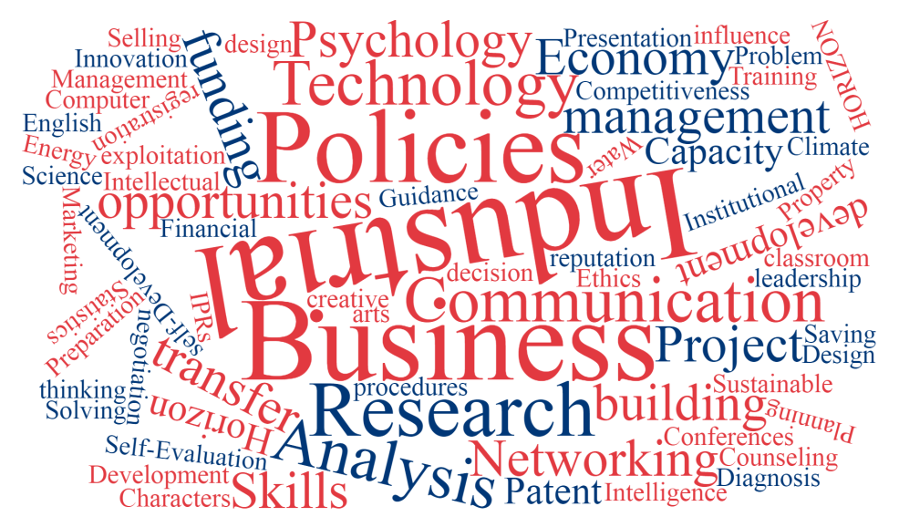

Previous working experience of participants mainly concerns the transfer of technologies and the technological support to enterprises. The set of involved people is however quite heterogeneous also under this aspect and not specifically addressed to the tasks they should accomplish in their work at CTIs. The following tag cloud gives an idea of this high level of heterogeneity.

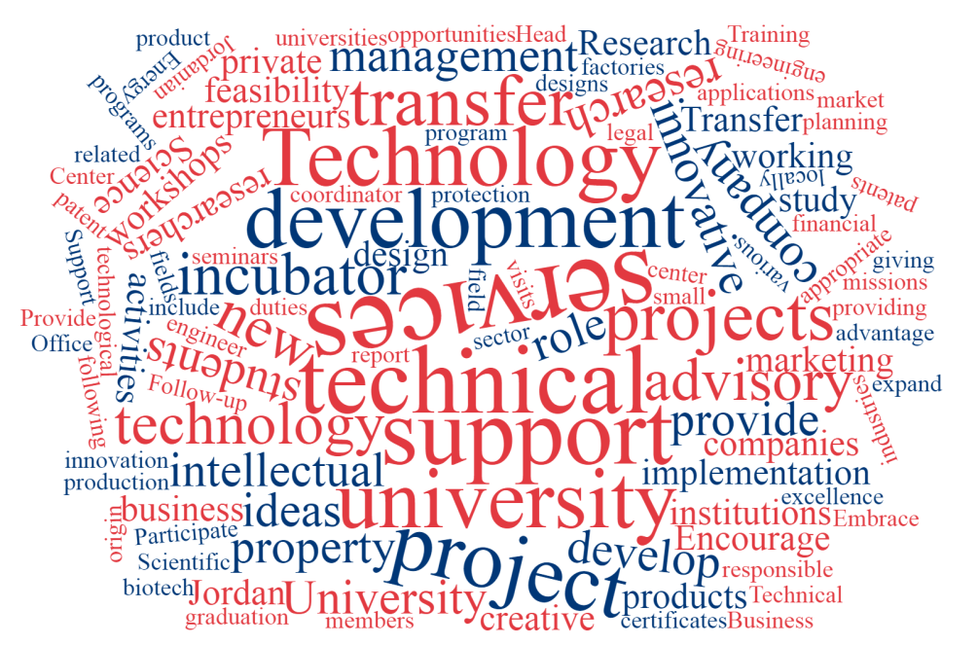

Particular regard has been paid in asking to the participants about business/work field indicating innovation aspects and targeted market. With regard to that we can summarize their answers as follows:

* Increasing the research activities to meet the society requirements of applied research
* Improving Reaserch facilities and technology transfer
* Enanching the reaserch of fund raising
* Improving communicating skills
* Driving and sustaining an active research culture that fosters high achievements
* Managing grants

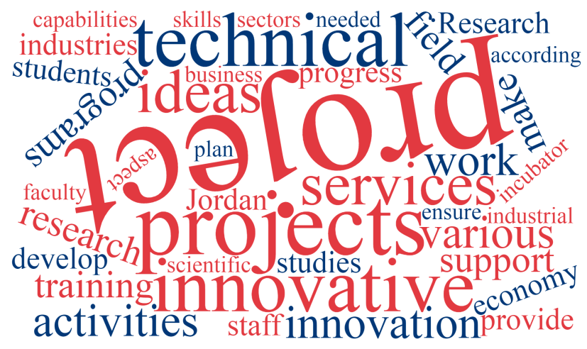

With regard to previous experience and workling life, we finally asked to participants some information about already existing relationship among their organisation and other bodies, if any, in order to see if any structure of networking already exists and how. The following table gives the structure of the consolidated affiliations and shows how the connection is already strong expecially among Universities, less with the private world:

|  |  |
| --- | --- |
| **Which of the following type of institutes are you affiliated with?** |  |
| Academic institution | 12 |
| Service provider | 9 |
| Entrepreneurial entity | 8 |
| Research lab/center | 8 |
| Public sector | 4 |

The last part of the questionnaire gave us important information on the needs expressed by trainees: as people with an high educational level and already experienced in the academic world, it was in fact important to listen to their opinion and test their level of awareness in oder to better decide which kind of contents it could be useful to develop during their training visits at EU partner bodies.

The main answers to the basic questions concerning technological needs for a CTI and cooperation needs for this kind of organisation to be born, are described in their main aspects in the two following tables:

|  |
| --- |
| **Technological needs which are supposed to be beneficial for the institution/company in a CTI** |
| Building capacity on best practices on innovation and technology transfer. Encouraging industrial sector to invest in applied research results. Smart learning and virtual labs. Access to the experience for other institutions dealing with TT in many fields. Development of networking for TT. Networking with others technological incubators in order to exchange knowledge, information and expertise. Building an entrepreneurship empowerment program for start-ups. Developing enterprises innovation strategy. Assistance with business plans, strategic planning, marketing, product commercialization, and financing. Consultation and referral regarding intellectual property issues. |

|  |
| --- |
| **What type of cooperation would you like to have with the similar entity?** |
| Share knowledge and experience. Corporation related to technology transfer. Training on issues related to technology transfer. Networking and partnership. New ideas and projects. Establishing a complete service platform, between the EU and Jordan research centers, universities and SMEs with a view to support: technology transfer, business matching, joint projects, and the operational development of new firms ( start-up, and spin-off). Reinforcing the mutual capacity to present opportunities, facilitate investments and help the localization of enterprises and research centers in both countries. Gaining knowledge of their experience through workshops or training courses. |

Finally, participants expressed their opinion on the support path they would like to have in the European hosting institutions. Their main answers said:

* Capacity building and know-how of staff through training and study tours covering different aspects of technology transfer concepts.
* Innovation in education, teaching and assessment strategies.
* Training to learn how to develop self capabilities to be able to transfer knowledge to others
* How to build strategic plan for TT for the long term.
* How to get benefit of European support and build partnering with European countries (specially through Horizon 2020).
* Business incubation and technology transfer (6)
* Joint technology transfer international network with the EU
* Trainings and workshops on technological developments and Entrepreneurship.

And the most needed skills they need to sharpen:

|  |  |
| --- | --- |
| **What are the most needed skills aspects you need to sharpen?** |  |
| Innovation process development | 14 |
| Technology management and transfer | 14 |
| Commercialization | 13 |
| Open Innovation | 12 |
| Project Management | 11 |
| Incubation services | 9 |
| Technical, Business | 5 |
| Branding | 5 |

# Contents of the training and programme of activities

As foreseen in the project, training and acquaintance with experience of EU co-beneficiaries will be carried out in EU countries. The reason for this choice, was that face-to-face practical training is the most efficient form of training. 3 study-visits are planned. According to the project and to what decided during transnational meetings, training of CTI staff in the EU will be implemented as follows:

* 1st week in March 2017: 16 flows from Partner Country (PC) to European Union (EU) (average 6 days each);
* 2nd week in September 2017: 16 flows Jordan to EU (average 6 days each);
* 3d week in January 2018: 16 flows from the Jordan to EU (average 6 days each).

As described in the analyses above, knowledge and experience of the 16 people is quite spread out on different topics, however needs expressed together with the training suggested by faculty members and industrial representatives, can be grouped in 4 macro-topics:

|  |
| --- |
| 1. **BUSINESS DEVELOPMENT, INCUBATION SERVICES AND TECHNOLOGIES TRANSFER SKILLS** |
| This topic includes training to be offered on typical activities of an incubator / TT centre, in particular:   * Business plan development * Coaching and mentoring to young entrepreneurs * Startup processes: incubation and acceleration * Technological development and entrepreneurship * Technology management and transfer * Transfer of research results into the market: methodologies and case studies * Technology transfer processes: from the identification of new solutions to their adoption in a perspective of enhancement and exploitation of research results in the market * How to build strategic plan for technology transfer for the long term |

|  |
| --- |
| 1. **FUNDRAISING, PROJECT PLANNING AND PROJECT MANAGEMENT SKILLS** |
| This topic includes training to be offered on:   * Principles and sources to find funds * Project planning methodologies * Project cycle management * Cooperation projects between Universities and industries: case studies * The EU programmes (specially Horizon 2020) * Project partnerships * How to get benefit of European support and build partnering with European countries |

|  |
| --- |
| 1. **INNOVATION** |
| This topic includes training to be offered on:   * Innovation processes * Innovation process development * Open innovation * Innovation in education, teaching and assessment strategies * Strategic innovation management * Innovation business models * Innovation, entrepreneurship ans sustainability |

|  |
| --- |
| 1. **CTI TRANSVERSAL MANAGEMENT SKILLS** |
| This topic includes training to be offered on:   * Communication techniques * Commercialization * Branding * Networking methodologies and techniques * Mechanisms to promote applied research outcomes at universities: case studies * CTI management: case studies and best practices |

In order to cover the above described request and in accordance with the agreed calendar, INVENT training will be delivered as follows:

## IV.1 First training week: March 2017

Each host organisation will receive the visit of 4 Jordan staff units, i.e.:

1. University of Deusto (Spain) will host 4 staff units
2. Paulo & Beatriz Consultores Associados, Lda (Portugal) will host 4 staff units
3. Consorzio ARCA, Palermo (Italy) will host 4 staff units
4. University of Cyprus, Nicosia (Cyprus) will host 4 staff units

The training to be delivered to them during the first week will be a combination of:

1. **traditional training** (with host organisation staff and/or external experts): collective training sessions in the form of seminars on the above mentioned topics, also through innovative tools helping to support formal and informal cooperation at intra and inter-organizational levels, including knowledge management systems and collaborative work environments.
2. **mentoring** (with host organisation staff): assisting on individual and group work aspects of their work if CTI staff units have the need to discuss problems, questions, etc.
3. **interrelations with local ecosystem:** CTI staff units will visit incubators, research labs, infrastructures, local stakeholders, in order to interact with a sort of microsystem and start to learn how to do networking. They will participate, if the case, to events, conferences, etc.

Indicative programme for the first week:

|  |  |  |
| --- | --- | --- |
| **Topic** | **First Training week** | **Duration in hours** |
| ***Day 1 – Monday*** | | |
|  | Welcome at HOST ORGANISATION  Presentation by the host organisation legal representative  Visiting host organisation spaces | 1 |
|  | Presentation of the participants: knowledge, experience, expectations (15 minutes each) | 1 |
|  | Seminar on Topic 1: Level 1.  Seminar will be held by an expert on the topic. | 2 |
|  | Cultural visit of the town (to be organised by the host organisation) | 3 |
| ***Day 2 – Tuesday*** | | |
|  | Seminar on Topic 2: Level 1.  Seminar will be held by an expert on the topic. | 2 |
|  | Seminar on Topic 3: Level 1.  Seminar will be held by an expert on the topic. | 2 |
|  | Individual work/study on a repository of traininig material on topic 1 provided by the host organization (documents, links to talks, videos, etc.) | 2 |
|  | Group workto draw up a joint report on the training week contents and get new ideas for initiating change and organise their future institutions (CTIs). | 2 |
| ***Day 3 – Wednesday*** | | |
|  | Seminar on Topic 4: Level 1.  Seminar will be held by an expert on the topic. | 2 |
|  | Seminar on Topic 1: Level 2.  Seminar will be held by an expert on the topic. | 3 |
|  | Individual work/study on a repository of traininig material on topic 2 provided by the host organization (documents, links to talks, videos, etc.) | 2 |
|  | Group workto draw up a joint report on the training week contents and get new ideas for initiating change and organise their future institutions (CTIs). | 1 |
| ***Day 4 – Thursday*** | | |
|  | Technical visits to incubators, research labs, infrastructures, local stakeholders (to be organised by the host organisation) | 4 |
|  | Individual work/study on a repository of traininig material on topic 3 provided by the host organization (documents, links to talks, videos, etc.) | 2 |
|  | Group workto draw up a joint report on the training week contents and get new ideas for initiating change and organise their future institutions (CTIs). | 2 |
| ***Day 5 – Friday*** | | |
|  | Technical visits to incubators, research labs, infrastructures, local stakeholders (to be organised by the host organisation) | 4 |
|  | Individual work/study on a repository of traininig material on topic 4 provided by the host organization (documents, links to talks, videos, etc.) | 2 |
|  | Plenary presentation by the 4 staff units to the host organisation of the joint report.  Discussion and identification of follow-up activities and field for future collaboration. | 2 |
| ***Day 6 – Saturday*** | | |
|  | Departure of participants |  |

## IV.2 From March 2017 to September 2017

From the first week to the second week of training abroad (therefore between March and September 2017), the 16 staff units will be grouped in 4 groups according to the 4 topics. Each group will have to be made of 4 people coming from the abroad experience made in a different Country and will concentrate their study/work on one of the topics. In synthesis, staff units will form the following groups:

|  |
| --- |
| **GROUP 1 working on BUSINESS DEVELOPMENT, INCUBATION SERVICES AND TECHNOLOGIES TRANSFER SKILLS** |
| 1 person who spent the first week in Portugal  1 person who spent the first week in Spain  1 person who spent the first week in Italy  1 person who spent the first week in Cyprus |
| **GROUP 2 working on FUNDRAISING, PROJECT PLANNING AND PROJECT MANAGEMENT SKILLS** |
| 1 person who spent the first week in Portugal  1 person who spent the first week in Spain  1 person who spent the first week in Italy  1 person who spent the first week in Cyprus |
| **GROUP 3 working on INNOVATION** |
| 1 person who spent the first week in Portugal  1 person who spent the first week in Spain  1 person who spent the first week in Italy  1 person who spent the first week in Cyprus |
| **GROUP 4 working on CTI TRANSVERSAL MANAGEMENT SKILLS** |
| 1 person who spent the first week in Portugal  1 person who spent the first week in Spain  1 person who spent the first week in Italy  1 person who spent the first week in Cyprus |

In this way the staff units can exchange the experience and telling the others what they learnt in the EU contries, keep working and discuss on interesting matters being followed at distance in order to multiplicate the effectiveness of the delivered training. Social networks (groups on facebook) and distance tools (skype, dropbox, etc.) will help in this phase.

Each group will have one tutor following them, coordinating them in a **forum for discussion** and continuous learning on themes of common interest, for exchanging innovative ideas and practices and enhancing key competences, and suggesting them material to read, themes to discuss or work to do, in a EU country. In particular:

* Consorzio ARCA, Palermo (Italy) will tutor Group 1
* University of Deusto (Spain) will tutor Group 2
* University of Cyprus, Nicosia (Cyprus) will tutor Group 3
* Paulo & Beatriz Consultores Associados, Lda (Portugal) will tutor Group 4

Tutors will organize one skype conference with the members of the group each month in order to better define the work to be developed at distance.

*(this is a proposal: host organizations can propose themselves for being tutor in another group).*

## IV.3 Second training week: September 2017

Each host organisation will receive the visit of the same 4 Jordanian staff units of the first week. The training to be delivered to them during the second week will be structured in a similar way of the first week but more concentrated on a more advanced level (Level 2) of topics 2, 3 and 4.

Indicative programme for the second week:

|  |  |  |
| --- | --- | --- |
| **Topic** | **Second Training week** | **Duration in hours** |
| ***Day 1 – Monday*** | | |
|  | Presentation by the representative of each group of the work undertaken during the period March-September | 4 |
|  | Cultural visit of the town (to be organised by the host organisation) | 4 |
| ***Day 2 – Tuesday*** | | |
|  | Seminar on Topic 2: Level 2.  Seminar will be held by an expert on the topic. | 3 |
|  | Seminar on Topic 3: Level 2.  Seminar will be held by an expert on the topic. | 3 |
|  | Individual work/study on a repository of traininig material on topic 2 provided by the host organization (documents, links to talks, videos, etc.) | 2 |
| ***Day 3 – Wednesday*** | | |
|  | Seminar on Topic 4: Level 2.  Seminar will be held by an expert on the topic. | 3 |
|  | Individual work/study on a repository of traininig material on topic 3 provided by the host organization (documents, links to talks, videos, etc.) | 2 |
|  | Group workto draw up a joint report on the training week contents and get new ideas for initiating change and organise their future institutions (CTIs). | 3 |
| ***Day 4 – Thursday*** | | |
|  | Technical visits to incubators, research labs, infrastructures, local stakeholders (to be organised by the host organisation) | 4 |
|  | Individual work/study on a repository of traininig material on topic 4 provided by the host organization (documents, links to talks, videos, etc.) | 2 |
|  | Group workto draw up a joint report on the training week contents and get new ideas for initiating change and organise their future institutions (CTIs). | 2 |
| ***Day 5 – Friday*** | | |
|  | Technical visits to incubators, research labs, infrastructures, local stakeholders (to be organised by the host organisation) | 4 |
|  | Plenary presentation by the 4 staff units to the host organisation of the joint report.  Discussion and identification of follow-up activities and field for future collaboration. | 2 |
|  | Joint work on the setting up, structure and valorization of the CTIs in Jordan. | 2 |
| ***Day 6 – Saturday*** | | |
|  | Departure of participants |  |

## IV.4 From September 2017 to January 2018

In the period between the second and the third training week, staff units will work for the first two months with the same structure of the above mentioned groups, followed by the European tutors.

Then they will group accordingly to the CTI where they are going to work. These new groups will therefore be:

* Group A: Staff units who will work at **CTI JUST**
* Group B: Staff units who will work at **CTI UJ**
* Group C: Staff units who will work at **CTI MU**
* Group D: Staff units who will work at **CTI PSUT**
* Group E: Staff units who will work at **CTI ASRF**
* Group F: Staff units who will work at **CTI AULE**

The groups will work during this period in studying local territories where their CTI will work and creating/strengthening local ecosystems. Basically the groups will work on (each one for the territory of local relevance):

* Mapping the territorial ecosystem
* Co-organise participative workshops (focus groups, events, etc.)
* Establishing cooperation agreements with the business world
* Set up local networking through the definition of a stakeholders matrix.

## IV.5 Third training week: January 2018

During the third week of training the competence development process will be enriched through *CTI staff units peers* and the chance of working togetherwiththe EU colleagues on a plan for the optimization and improvement of the services to be delivered by their structures.

The destination of the CTI units will change as staff units who will work in the same CTI will travel together. Indicatively, we can foresee that:

1. University of Deusto (Spain) will host CTI ASRF staff units
2. Paulo & Beatriz Consultores Associados, Lda (Portugal) will host CTI AULE staff units
3. Consorzio ARCA, Palermo (Italy) will host CTI JUST and CTI JO staff units
4. University of Cyprus, Nicosia (Cyprus) will host CTI MU and CTI PSUT staff units

*(this is a proposal: host organizations can propose themselves for hosting a different CTI staff group)*

Indicative programme for the third week:

|  |  |  |
| --- | --- | --- |
| **Topic** | **Third Training week** | **Duration in hours** |
| ***Day 1 – Monday*** | | |
|  | Presentation by the representative of each CTI of the topic content, the training received and the mapping work done during the previous months. | 4 |
|  | Discussion and enrichment of the territorial ecosystem | 4 |
| ***Day 2 – Tuesday*** | | |
|  | Seminar on Business Planning and Canvas | 4 |
|  | Workshop on how to develop a Business Plan for the CTI | 4 |
| ***Day 3 – Wednesday*** | | |
|  | Workshop on how to develop a Business Plan for the CTI | 4 |
|  | Tutorship on the development plan of the CTI | 4 |
| ***Day 4 – Thursday*** | | |
|  | Each CTI staff will work together with host organisation staff to the development of the CTI Business Plan | 8 |
| ***Day 5 – Friday*** | | |
|  | Seminar on successful case studies of exisiting structures similar to CTIs | 6 |
|  | Plenary presentation by the CTI staff units to the host organisation of the relative CTI business plan and strategy of development. | 2 |
| ***Day 6 – Saturday*** | | |
|  | Departure of participants |  |

# Evaluation of the training

At the end of each training week, both CTI staff units and host organisation will have the chance to evaluate their experience. Study visit reports from the participants (Annex 1) and reports from the host institutions (Annex 2) will help the WP leader to draw up conclusions and assess results from the staff capacity building process. Information and statistics extracted from final reports as well as evaluation and assessment forms will be the base of the final report concerning this WP.

# Annex 1 –Questionnaire for the evaluation of host organizations

# (to be filled by CTIs’ staff trained)

*Instructions: Please give your answers or comments in writing, or indicate the extent to which you gained confidence in the topics you learnt in the mobility to the EU host.*

*The scale is 1-5*

|  |  |  |  |  |  |  |  |
| --- | --- | --- | --- | --- | --- | --- | --- |
| **Date …./……./……..** | | CTI staff evaluation of host institutes | | **Questionnaire number** | | | |
|  |  |  |  |
|  | **Units staff name ……….………….……** | | **Host institute Country:** | | | | |
| **Organization name: ……….…………..** | |
|  | **Q1: Organization place:** | | | | | | |
|  | **Q2: Type of organization:** | | | | | | |
| 1. Research 2. Public organization 3. Private 4. Other**……….………….…..** | | | | | | |

|  |  |  |  |  |  |  |
| --- | --- | --- | --- | --- | --- | --- |
| **Section one: units staff background** | | | | | | |
| 1 | What are the most useful activities/ visits you had during your stay in the EU hosts? why | | | | | |
| 2 | What are the least useful activities/ visits you had during your stay in the EU hosts? why | | | | | |
| 3 | List the most useful lesson learned | | | | | |
| 4 | How was the study visit useful to your work? What type of knowledge you will take back home? | | | | | |
| **Section two: To what extent did you gain confidence in the following topics you learnt?** | | | | | | |
| ***Background*** | | Not at all | Not well | Neutral | Well | Very well |
| 1 | Leadership and presentations | 1 | 2 | 3 | 4 | 5 |
| 2 | Open Innovation and living labs | 1 | 2 | 3 | 4 | 5 |
| 3 | Transfer of technology processes | 1 | 2 | 3 | 4 | 5 |
| 4 | OTHER TO BE DEFINED | 1 | 2 | 3 | 4 | 5 |
| 5 | Other (please specify) | 1 | 2 | 3 | 4 | 5 |
| **Section three: the host institute environment** | | Not at all | Not well | Neutral | Well | Very well |
| 1 | The training was suitable and in good environment | 1 | 2 | 3 | 4 | 5 |
| 2 | The study visits were relevant and useful | 1 | 2 | 3 | 4 | 5 |
| 3 | The people we met during the visit were of great value added. | 1 | 2 | 3 | 4 | 5 |
| 5 | What were the biggest obstacles and problems? | | | | | |
| 6 | Your suggestions for improvements: | | | | | |

# Annex 2 - Questionnaire for the evaluation of CTIs’ staff

# (to be filled by host organizations)

|  |  |  |  |  |  |  |  |
| --- | --- | --- | --- | --- | --- | --- | --- |
| **Date …./……./……..** | | **Host organisation questionnaire for units staff** | | **Questionnaire number** | | | |
|  |  |  |  |
|  | **Host institute Name………….…………….** | | **Host institute country** | | | | |
| **Staff Name: ……….…………………….…..** | |
| **Section one: units staff background** | | | | | | | |
|  | **Q1: Organization name:** | | | | | | |
|  | **Q1: Organization place:** | | | | | | |
|  | **Q2: Type of organization:** | | | | | | |
| 1. Research 2. Public organization 3. Private 4. Other,……………………… | | | | | | |
| **Section two: Commitment of the unit staff 1…5 (1: very weak, 2: weak, 3: fair, 4: good, 5: excellent)** | | | | | | | |
|  | **Question** |  | **Score 1-5** | **Comments** |  |  |  |
| 1 | The participant was committed to the visit and schedule |  |  |  | | | |
| 2 | The participant showed huge interest in the program |  |  |
| 3 | The participant knows well his goal from the visit |  |  |
| **Section three: Tasks accomplishment 1…5 (1: very weak, 2: weak, 3: fair, 4: good, 5: excellent)** | | | | | | | |
|  | **Question** |  | **Score 1-5** | **Comments** |  |  |  |
| 1 | The participant accomplished his/her tasks completely |  |  |  | | | |
| 2 | The participant has innovation aspects in doing the tasks |  |  |
| 3 | The participant knows well about … TO BE DEFINED |  |  |
| **Section four: Communication and practical skills 1…5 (1: very weak, 2: weak, 3: fair, 4: good, 5: excellent)** | | | | | | | |
|  | **Question** |  | **Score 1-5** | **Comments** |  |  |  |
| 1 | The participant has good communication skills |  |  |  | | | |
| 2 | The participant has the know-how skills in his field |  |  |
| 3 | The participant knows what he is doing and for what |  |  |
| **Section five: Lessons learned and outcomes** | | | | | | | |
|  | **Question** | | **(Yes, No)** | **Comments** | | | |
| 1 | The participant came up with the best practices report |  |  |  | | | |
| 2 | The participant cooperated with networks during his stay |  |  |
| 3 | The participant signed agreements with any similar companies or units |  |  |
| **Section six: Overall assessment on skills 1…4 (1: strongly disagree, 2: disagree, 3: agree, 4: strongly agree)** | | | | | | | |
|  | **Question** |  | **Score 1-4** | **Comments** |  |  |  |
| 1 | Leadership |  |  |  | | | |
| 2 | Creativity and innovation |  |  |
| 3 | Time and self-management |  |  |
| 4 | Work under pressure |  |  |
| 5 | Ability to work in a team |  |  |
| 6 | Planning and organizational skills |  |  |

1. The answers to the most relevant questions were analysed with a text analysis tool and a synthetic graph representing them prepared: the tag cloud is a visual representation of text data, typically used to depict keyword metadata (tags) or to visualize free form text. Tags are usually single words, and the importance of each tag is shown with font size or color.This format is useful for quickly perceiving the most prominent terms and for locating a term alphabetically to determine its relative prominence.